Sprint 3 Meeting Evidence
Project: Campus Food Ordering Platform
Sprint: Sprint 3
Evidence Type: Meeting screenshots and Scrum communication evidence
Meeting Screenshots Included
1. Sprint 3 Planning Meeting
Date: 24 April 2026
Duration: 30 minutes
Purpose: Sprint 3 planning, payment feature planning, dietary system planning, and task dependency order.
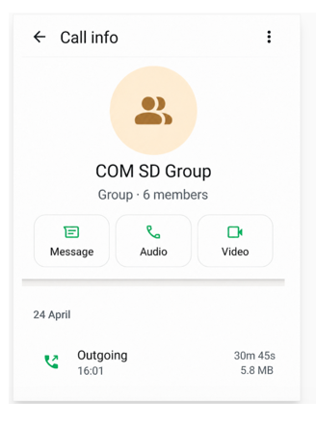
2. Sprint 3 Progress Meeting
Date: 30 April 2026
Duration: 16 minutes
Purpose: PayFast decision, one-vendor checkout rule, paid orders, active orders, order history, and dietary options.
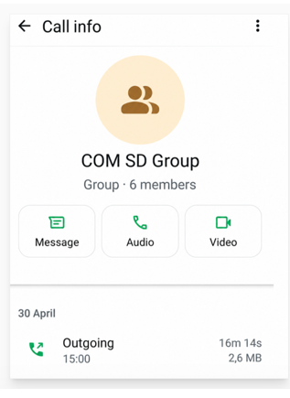
3. Sprint 3 Progress Meeting
Date: 8 May 2026
Duration: 15 minutes
Purpose: Payment progress, student-side progress, vendor-side review, and dietary feature progress.
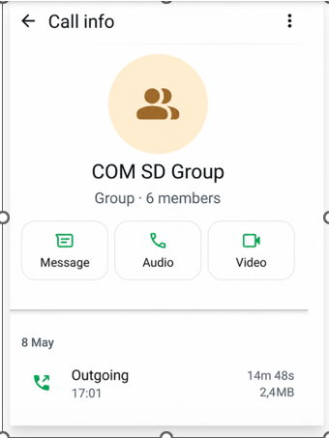
4. Sprint 3 Final Progress / Merge Preparation Meeting
Date: 10 May 2026
Duration: 12 minutes
Purpose: Confirm all Sprint 3 parts completed, prepare main branch merge, and update UML diagrams.
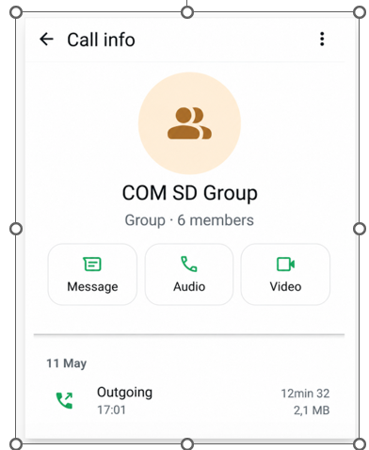
5. Sprint 3 Review Meeting
Date: 11 May 2026
Duration: 17 minutes
Purpose: Sprint 3 review, completed payment and dietary features, branch issues, communication improvements, and next sprint actions.
